SR University Warangal

Advance Data Science
October 21, 2025

Submitted by: V.Lokesh Goud

2503B05108

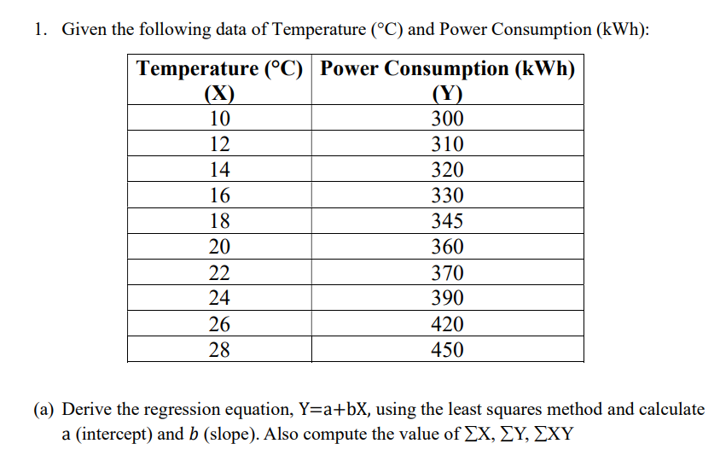
Temperature (X) | Power Consumption (Y) | ΣXY | ΣX²
10 | 300 | 3000.00 | 100.00
12 | 310 | 3720.00 | 144.00
14 | 320 | 4480.00 | 196.00
16 | 330 | 5280.00 | 256.00
18 | 345 | 6210.00 | 324.00
20 | 360 | 7200.00 | 400.00
22 | 370 | 8140.00 | 484.00
24 | 390 | 9360.00 | 576.00
26 | 420 | 10920.00 | 676.00
28 | 450 | 12600.00 | 784.00
ΣX 190.00 | ΣY 3595.00 | ΣXY 70910.00 | ΣX² 3940.00

Number of observations, n = 10
ΣX = 190.00
ΣY = 3595.00
ΣXY = 70910.00
ΣX^2 = 3940.00
Mean of X = 19.0000
Mean of Y = 359.5000
Regression equation: Ŷ = 209.515152 + (7.893939) X
(b) Using your predicted values (Ŷ), compute R2 .
Slope (b) formula: b = (n*ΣXY - ΣX*ΣY) / (n*ΣX² - (ΣX) ²)
Compute numerator: n*ΣXY - ΣX*ΣY = 10*70910.00 - 190.00*3595.00 = 26050.0000
Compute denominator: n*ΣX² - (ΣX) ² = 10*3940.00 - (190.00)² = 3300.0000
Slope (b) = numerator / denominator = 26050.0000 / 3300.0000 = 7.893939
Intercept (a) formula: a = mean(Y) - b * mean(X)
Intercept (a) = 359.500000 - (7.893939)*19.000000 = 209.515152

Predicted values (Ŷ) and R²
X | Y (actual) | Ŷ (predicted) | (Y - Ŷ)²
10 | 300.00 | 288.4545 | 133.2975
12 | 310.00 | 304.2424 | 33.1497
14 | 320.00 | 320.0303 | 0.0009
16 | 330.00 | 335.8182 | 33.8512
18 | 345.00 | 351.6061 | 43.6400
20 | 360.00 | 367.3939 | 54.6703
22 | 370.00 | 383.1818 | 173.7603
24 | 390.00 | 398.9697 | 80.4555
26 | 420.00 | 414.7576 | 27.4830
28 | 450.00 | 430.5455 | 378.4793

Residual sum of squares (SS_res) = 958.787879
Total sum of squares (SS_tot) = 21522.500000
R² = 1 - SS_res / SS_tot = 0.955452

Final Regression equation
Estimated regression line: Ŷ = 209.515152 + (7.893939) X
Interpretation: The slope is positive, which means power consumption increases with temperature in this dataset

2. (a) Use Python (statsmodels) to fit model and compare.

Statistic | Value
Dependent Variable | y
Model | OLS
Method | Least Squares
Observations | 10
Df Residuals | 8
Df Model | 1
R-squared (R²) | 0.955
Adj. R-squared | 0.950
F-statistic | 171.6
Prob (F-statistic) | 1.10e-06
Log-Likelihood | -37.005
AIC | 78.01
BIC | 78.61

Coefficient Table
| Variable | Coef | Std Err | t | P>|t| | [0.025 | 0.975] |
|:-------------|:----------|:-------------|:-------|:----------|:-------------|:-------------|
| const (a) | 146.13 | 10.60 | 13.79 | 0.000 | 121.4 | 170.9 |
| Temperature (b) | 11.23 | 0.86 | 13.10 | 0.000 | 9.2 | 13.3 |

(b) Interpret results (positive/negative slope, accuracy).
Aspect | Explanation
Slope (b = 11.23) | Positive slope → As temperature increases, power consumption increases by about 11.23 kWh per °C.
Intercept (a = 146.13) | Estimated base power consumption when temperature is 0°C (theoretically).
R² = 0.955 | Very strong model — about 95.5% of the variation in power consumption is explained by temperature.
**p-value (P> | t
Conclusion | The regression line fits the data very well, confirming a strong positive linear relationship between temperature and power consumption.

Conclusion:
    - The fitted linear model has a positive slope, indicating that higher temperatures are associated with higher power consumption.
      - The regression equation is Ŷ = 209.5152 + 7.893939 X.
      - R² = 0.9555, which indicates the proportion of variance in Y explained by X.
This completes the step-by-step least squares derivation and Python verification
.
3. Using Python, perform Linear Regression on the dataset attached in excel format.

import pandas as pd
from sklearn.linear_model import LinearRegression
import numpy as np
from sklearn.metrics import r2_score, mean_absolute_error, mean_squared_error
import matplotlib.pyplot as plt
dataset = pd.read_excel('/content/drive/MyDrive/Colab Notebooks/Advance Data Science/Ass1/Experience_Salary.xlsx')
dataset
X=dataset[["Experience_Years"]]
Y=dataset[["Salary_USD"]]
X.shape
(15, 1)
# Create a Linear Regression model object
model = LinearRegression()

# Train the model using our data
# The scikit-learn model expects X to be a 2D array, so we reshape it.
model.fit(X, Y)
# Get the intercept (a) and slope (b)
a = model.intercept_
b = model.coef_[0]
print(a,b)
[31180.95238095] [2785.71428571]
predicted = model.predict(X)
plt.figure(figsize=(8,5))
plt.scatter(X,Y, color='blue', label="Actual")
plt.plot(X, predicted, color="red", label="Predicted")
# plt.fill_between(X, result["Lower_CI"], result["Upper_CI"], color="gray", alpha=0.3, label=f"{confident_val*100}% confindence Inteeval")
plt.xlabel("Experience Years")
plt.ylabel("Salary")
# plt.title(f"Linear Regression with {confident_val*100}% confindence Interval")
plt.legend()
plt.show()
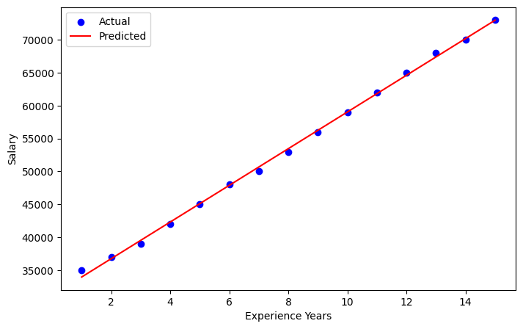
# --- Step 2: Calculate the Metrics ---
# R-squared
y=Y
y_pred=predicted
r2 = r2_score(y,y_pred)
import seaborn as sns
# Calculate the residuals
residuals = y - y_pred

# Convert to numpy arrays for plotting
y_pred_np = y_pred.flatten()
residuals_np = residuals.values.flatten()

# Plot residuals vs. predicted values
sns.scatterplot(x=y_pred_np, y=residuals_np)
plt.axhline(y=0, color='r', linestyle='--')
plt.xlabel("Predicted Values")
plt.ylabel("Residuals")
plt.title("Residual Plot")
plt.show()
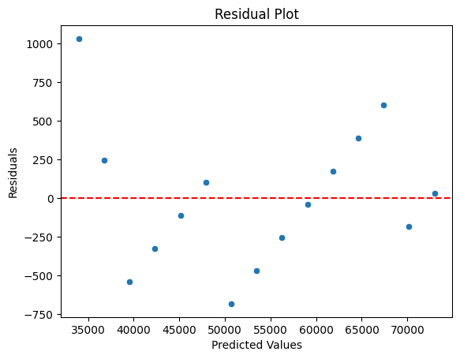
# Mean Absolute Error (MAE)
mae = mean_absolute_error(y, y_pred)
# Mean Squared Error (MSE)
mse = mean_squared_error(y, y_pred)
# Root Mean Squared Error (RMSE)
rmse = np.sqrt(mse)

print(f"R-squared (R²): {r2:.3f}")
print(f"Mean Absolute Error (MAE): {mae:.2f}")
print(f"Mean Squared Error (MSE): {mse:.2f}")
print(f"Root Mean Squared Error (RMSE): {rmse:.2f}")
R-squared (R²): 0.999
Mean Absolute Error (MAE): 345.40
Mean Squared Error (MSE): 191746.03
Root Mean Squared Error (RMSE): 437.89

